## VISVESVARAYA TECHNOLOGICAL UNIVERSITY, JNANASANGAMA, BELAGAVI- 590018



### BLDEA’s V.P. Dr. P.G. HALAKATTI COLLEGE OF ENGINEERING AND TECHNOLOGY, VIJAYAPUR



**DEPARTMENT OF**

**ELECTRONICS AND COMMUNICATION ENGINEERING**

A Major Project report on

**“SMART MEDICINE DISPENSER”**

*Submitted in partial fulfillment for the award of degree of Bachelor of Engineering in Electronics and Communication Engineering*

### Submitted by

**NAME OF STUDENT 1:RAKSHITA UMESH BAKALI USN OF STUDENT 1:2BL22EC073**

**NAME OF STUDENT 2:REVATI BHAVIKATTI USN OF STUDENT 2:2BL22EC077**

**NAME OF STUDENT 3:SHREYA.S.BIRADAR USN OF STUDENT 3:2BL22EC098**

**NAME OF STUDENT 4:SUSHMITA.A.BULAGOUDAR USN OF STUDENT 4:2BL22EC111**

### Under the Guidance of

### DR.S.K.PADAGANUR

**2025-26**

**VISVESVARAYA TECHNOLOGICAL UNIVERSITY, BELGAUM**



## B.L.D.E. Association’s

**V.P Dr. P.G HALAKATTI COLLEGE OF ENGINEERING AND TECHNOLOGY, VIJAYAPUR**



### DEPARTMENT OF ELECTRONICS AND COMMUNICATION ENGINEERING

**CERTIFICATE**

This is Certified that the Major project work entitled **“SMART MEDICINE DISPENSER”** carried out by **Rakshita Bakali, Revati Bhavikatti, Shreya Biradar, Sushmita Bulagoudar,** Bonafide students of **BLDEA’S V.P. Dr P.G Halakatti College of Engineering and Technology, Vijayapura** in partial fulfillment for the award of **Bachelor of Engineering** in **Electronics and Communication Engineering** of the **Visvesvaraya Technological University, Belgaum** during the year 2024-2025. It is certified that all corrections/suggestions indicated for internal assessment have been incorporated in the report deposited in the departmental library. The project phase-1 report has been approved as it satisfies the academic requirement in respect of Mini project work prescribed for the said degree.

|  |  |  |
| --- | --- | --- |
| **GUIDE** | **H.O.D** | **PRINCIPAL** |
| **Dr. S.K.PADAGANUR** | **Dr. J.S.GONAL** | **Dr. MANJUNATH.P** |

**B.L.D.E. Association’s**

**VACHANA PITAMAHA Dr. P.G. HALAKATTI COLLEGE OF**

**ENGINEERING & TECHNOLOGY, VIJAYAPURA**

DEPARTMENT OF ELECTRONICS & COMMINUCATION ENGINEERING

**DECLARATION**

We, students of Sixth semester B.E, at the department of Electronics & Communication Engineering, hereby declare that, the Mini Project entitled “ **SMART MEDICINE DISPENSER** ”,embodies the report of our mini project work, carried out by us under the guidance of **Dr S.K.PADAGANUR,**  We also declare that, to the best of our knowledge and belief, the work reported here in does not form part of any other report or dissertation on the basis of which a degree or award was conferred on an earlier occasion on this by any student.

Place:-VIJAYAPUR Date:-

## Name of the Students USN

## RAKSHITA UMESH BAKALI 2BL22EC073

## REVATI BHAVIKATTI 2BL22EC077

## SHREYA S BIRADAR 2BL22EC098

## SUSHMITA A BULAGOUDAR 2BL22EC111

**ACKNOWLEDGEMENT**

The satisfaction and euphoria that accompany the successful completion of any task would be incomplete without the mention of people who made it possible, whose consistent guidance and encouragement crowned our efforts with success. We consider it as our privilege to express the gratitude to all those who guided in the completion of our Mini Project.

First and foremost, We wish to express our profound gratitude to our respected Principal **Dr. Manjunath P, B.L.D.E. Association’s VACHANA PITAMAHA Dr.**  **P.G. HALAKATTI COLLEGE OF ENGINEERING & TECHNOLOGY, Vijayapura** , for providing us with a congenial environment to work in.

We would like to express our sincere thanks to **Dr. J S Gonal** , the HOD of **Electronics**  **and Communication Engineering**, **B.L.D.E. Association’s VACHANA PITAMAHA Dr. P.G. HALAKATTI COLLEGE OF ENGINEERING & TECHNOLOGY, Vijayapura**, for his continuous support and encouragement.

We are greatly indebted to our guide **Dr .S.K.PADAGANUR**, Department of **Electronics and**  **Communication Engineering**, **B.L.D.E. Association’s VACHANA PITAMAHA Dr. P.G. HALAKATTI COLLEGE OF ENGINEERING & TECHNOLOGY, Vijayapura**, who took great interest in our work. He motivated us and guided us throughout the accomplishment of this goal. We express our profound thanks for his meticulous guidance.

## Name of the Students USN

## RAKSHITA UMESH BAKALI 2BL22EC073

## REVATI BHAVIKATTI 2BL22EC077

## SHREYA S BIRADAR 2BL22EC098

## SUSHMITA A BULAGOUDAR 2BL22EC111

## ABSTRACT

In this era of modern medicine where humans are largely dependent on the use pills/tablets we know at least 1 or more who have to take their medication in the form of pills/tablets in order to live a healthy life.

In this project, we focus on a Smart automated machine which will help a person to take his/her pills on time according to a schedule and mainly focusing on making sure that your loved ones who are either old aged or having memory loss or have difficulty in remembering the medicine schedule take their pills on time from the touch of your phone around the world.

The project includes designing and fabrication of the body and the parts of the final product. Design will be done using software’s like Solid Works or AutoCAD.

The physical product will have PLC circuits and a Bi-directional rotating mechanism which will be enclosed inside the body of the product. This product will also be WI-FI enabled and has a dedicated smart app which can be downloaded on the phone.

It also has a colored LCD panel screen which is mounted on the body and be accessed with the buttons provided on the body.

# INDEX

**3**

|  |  |  |
| --- | --- | --- |
| **SI.NO** | **Name of Chapters** | **PAGE.NO** |
| **1** | **INTRODUCTION** | **2-4** |
| **2** | **LITERATURE SURVEY** | **5-7** |
| **3** | **METHODOLOGY** | **8-12** |
| **4** | **HARDWARE AND SOFTWARE REQUIREMENTS** | **13-20** |
| **5** | **RESULT** | **21-23** |
| **6** | **ADVANTAGES AND**  **DISADVATAGES** | **24-26** |
| **7** | **APPLICATIONS** | **27-28** |
| **8** | **CONCLUSION** | **29-30** |
| **9** | **FUTURE SCOPE** | **31-32** |
| **10** | **REFERENCE** | **32-34** |

**LIST 0F FIGURE**

|  |  |  |
| --- | --- | --- |
| **FIG.NO** | **NAME OF FIGURE** | **PAGE NO** |
| **3.1** | **PIN OUT DIAGRAM** | **10** |
| **3.2** | **MANUAL CONNECTION** | **11** |
| **3.3** | **ADRUINO IDE** | **12** |
| **4.1.1** | **ARDUINO UNO** | **15** |
| **4.1.2** | **JUMPER WIRES** | **15** |
| **4.1.3** | **SERVO MOTOR** | **16** |
| **4.1.4** | **BUZZER** | **16** |
| **4.1.5** | **IR SENSOR** | **17** |
| **4.1.6** | **16x2 LCD(I2C)** | **17** |
| **4.1.7** | **MEDICINE CONTAINER** | **18** |
| **5.1** | **HARDWARE WORKING** | **22** |
| **5.2** | **SYSTEM WORKFLOW AND DIAGRAM OF WORKING** | **23** |

**INTRODUCTION**

**CHAPTER: 1**

## INTRODUCTION

The Smart Medicine Dispenser is an automated system designed to assist individuals in taking their medication on time and in the correct quantity. With the increasing dependency on medicines for chronic illnesses, elderly care, and post-treatment routines, maintaining a proper medication schedule has become essential. However, many people forget to take their pills or accidentally consume the wrong dose, which can lead to serious health issues. This project addresses these challenges by using simple electronics and automation to dispense medicine in a safe, reliable, and user-friendly manner.

The system uses an IR sensor to detect when a pill is ready for dispensing, a servo motor to mechanically release the medicine, and a buzzer to alert the user. An LCD display provides real-time messages such as reminders, status notifications, and time-based labels like Morning, Afternoon, and Evening. Once the user is alerted, the device waits for a short duration before rotating the servo to dispense the pill. The system also keeps a count of the pills dispensed and stops automatically after a fixed number of doses, ensuring accuracy and safety.

The Smart Medicine Dispenser is especially useful for elderly patients, individuals with memory difficulties, and users with a busy lifestyle. By combining simple hardware with intelligent logic, the project demonstrates how embedded systems can enhance healthcare, improve medication adherence, and promote personal wellbeing. This innovation highlights the potential of low-cost automation in everyday life and contributes to smarter health-supporting technologies.

Top of Form

Bottom of Form

In today’s fast-paced world, ensuring timely and accurate medication intake is a growing challenge, especially among the elderly, chronically ill, and individuals with cognitive impairments. Non-adherence to prescribed medication schedules often leads to severe health complications, increased hospitalization rates, and higher healthcare costs. To address this pressing issue, technology offers a promising solution in the form of Smart Medicine Dispensers.

A Smart Medicine Dispenser is an automated device integrated with technologies such as the Internet of Things (IoT), sensors, alarms, and sometimes artificial intelligence (AI), to assist users in taking their medications correctly and on time. These systems are designed to store, schedule, and dispense medicines with minimal human intervention, ensuring adherence while providing real-time monitoring and alerts to caregivers or healthcare professionals.

This project aims to develop a prototype Smart Medicine Dispenser that can automate medication management, reduce human error, and enhance patient safety. By combining embedded systems with connectivity features, the dispenser ensures reliable operation and offers user-friendly interaction. The design particularly focuses on elderly care, with features such as visual and audio alerts, mobile notifications, and dose tracking.

Ultimately, this project contributes to the advancement of smart healthcare solutions, promoting better health outcomes and improved quality of life.

**LITERATURE SURVEY**

CHAPTER 2:

**LITERATURE SURVEY**

In this section we are going to see the Literature study on our concept that was previously done by some engineers, scientists and other personalities. Our literature study includes mainly 4 articles they were:

1. Smart Pill Box Health Care System.

2. Improving healthcare using Smart Pill Box for Medicine Reminder and

Monitoring System.

3. A Comprehensive Approach for a Smart Medication Dispenser.

4. Design and Development of Smart Medicine Box.

**1. A Comprehensive Approach for a Smart Medication Dispenser(July 2019)**

By *Abdallah Kassem , Wissam Antoun , Mustapha Hamad and Chady El- Moucary.* This paper presents a comprehensive approach for a Smart Medicine Dispenser(SMD) prototype. The main purpose of the proposed system is to help patients,mainly seniors and elderly people, take their medications on time in an easymanner without the possibility of skipping pills and thus reducing the risk ofaccidental over/under dose treatment. An Android application is developed that is responsible for controlling the whole system as it constitutes a data base awaited to be synchronized and on synchronization the data is sent by the application that determines which motor should be rotated.

***2.* Improving healthcare using Smart Pill Box for Medicine Reminder and**

**Monitoring System** by *Diaa Salama, Abdul Minaam.*

This paper consists on the conception, design and creation of a pillbox prototype intended to solve the deficiency in the medical area as it has the ability of sorting out the pills by itself .The medication pill box is focused on patients who frequently take medications or vitamin supplements, or attendants who deal with the more seasoned or patients.

It has 9 compartment boxes as the previous paper consists three and it has alert remainder set through android application. The pillbox will remind clients or patients to take pills utilizing sound and light.

**3. Smart Pill Box Health Care System (July 2018)** by *Nidhi Solanki, DR. P. H. Zope.*

This Smart Pill Box was designed using GSM technology by which the system sends SMS alerts to the consumers or patients to their mobile phones like a remainder message. They used a pill box system containing three separate small pillboxes. Each box has a led display placed on the box. For the pill system, the user can store up to three different types of pills, which can be stored in those three small separate boxes.

There main objective was to provide fast curing of patients by taking medicines on time in an appropriate dosage and in an efficient manner.

**4. Design and Development of Smart Medicine Box(2018)**

By *Ekbal Rosli and Yusnira Husaini.*

This smart medicine box was designed and develop to help the introvert patients taking their medicines without the help of others. They developed a robot which replaces the nurses in the hospital which avoided emotional disturbance in between the nurses and the introvert patients. They used IOT technology to control the medicine box which used sensors and robotic programming to store the data base and response

would take place based on the data given by the patient or the nurse whose attends th

METHODOLOGY

# CHAPTER: 3

METHODOLOGY

The methodology of the Smart Medicine Dispenser project focuses on designing a simple, reliable, and automated system that assists users in managing their medication schedule. The development process is divided into several systematic steps that include hardware setup, sensor integration, logic implementation, and testing.

1. **Hardware Setup**

The system is built using an Arduino microcontroller, an IR sensor, a servo motor, a buzzer, and a 16×2 I2C LCD display. The IR sensor is positioned near the pill outlet to detect the presence of a pill. The servo motor is connected to the dispensing mechanism to rotate and release the pill when required. The buzzer is included to alert the user, and the LCD display is used for providing messages and status information.

The hardware setup of the Smart Medicine Dispenser involves assembling and connecting all the electronic components required for automatic pill dispensing. Each component is selected for a specific purpose and is carefully interconnected to ensure smooth functioning of the system.

**i. Arduino Microcontroller**

The Arduino Uno acts as the central processing unit of the system. It controls all other components by receiving signals, processing the logic, and generating output commands. The digital and PWM pins of the Arduino are used to read sensor values and drive the servo motor.

**ii. IR Sensor**

The IR sensor is positioned near the pill outlet to detect the presence of a pill. It works by emitting infrared light and sensing the reflected light. When a pill blocks the IR beam, the sensor output changes, which the Arduino reads to trigger the dispensing process. The sensor’s VCC, GND, and OUT pins are connected to the Arduino.

**iii. Servo Motor**

A small SG90 or MG90S servo motor is used to rotate the dispensing mechanism. It is connected to a PWM pin on the Arduino to allow precise angle control. The servo receives a control signal from the Arduino and rotates to drop a pill when needed. Because servo motors need stable power, they are supplied with 5V and share a common ground with the Arduino.

**iv. Buzzer**

The buzzer is used to alert the user before dispensing the medicine. It is connected to a digital output pin of the Arduino. When activated, the buzzer produces a sound notification, indicating that the medicine is ready to be taken.

**v. LCD Display (16×2 I2C)**

The 16×2 I2C LCD display is used to show messages like “Ready to Take Medicine,” “Medicine Dispensed,” pill count, and time labels such as Morning, Afternoon, and Evening. The I2C module allows communication using only two wires—SDA and SCL—making wiring simple and efficient. The display is powered through the Arduino’s 5V and GND pins.

**vi. Power Supply and Wiring**

All components are powered using a regulated 5V supply. The servo motor may require an external 5V power source if it draws more current. The most important requirement is that **all grounds must be connected together**, ensuring stable operation. Jumper wires and a breadboard are used to make secure and organized connections between components.

Top of Form

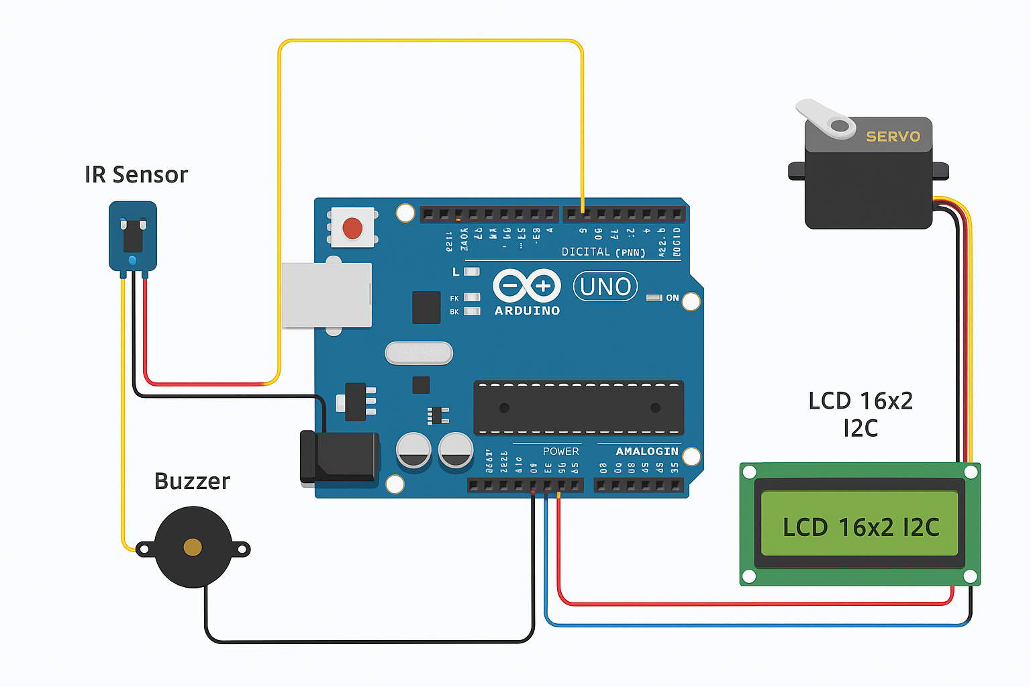Bottom of Form

**Fig-3.1 PIN OUT DIAGRAM**

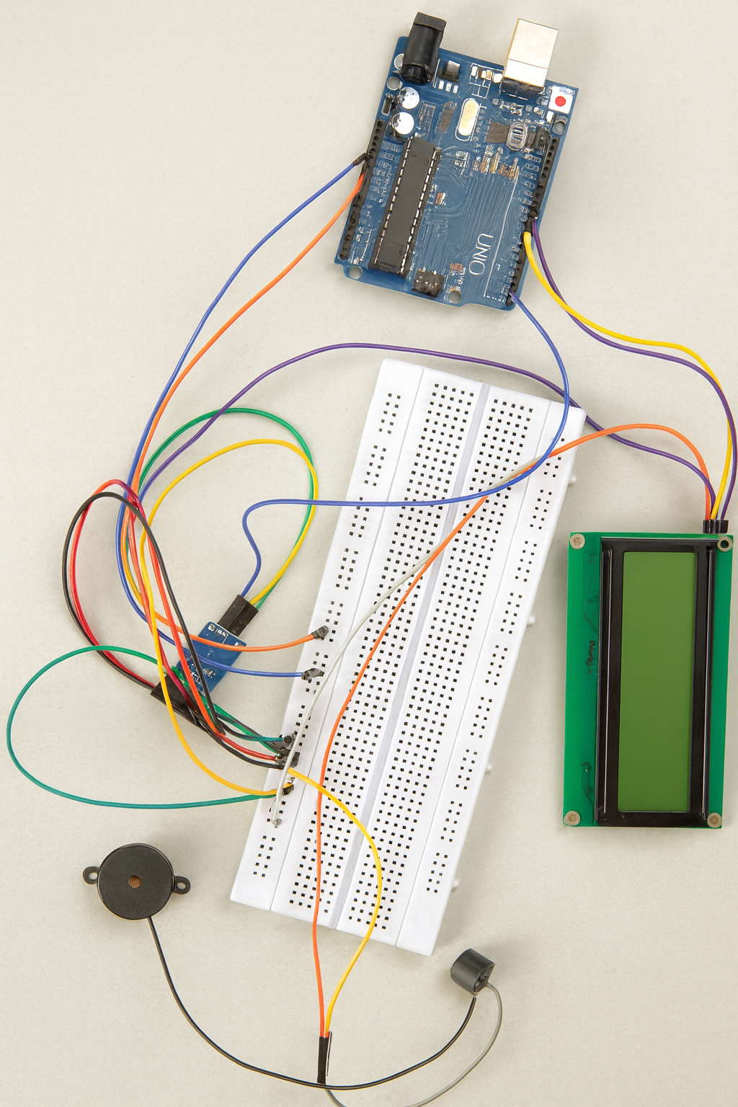

**Fig 3.2-Manual Connection**

**2.Software Logic Development**

The main control algorithm is written in Arduino programming language. The logic is divided into the following steps:

* The system initializes and displays a startup message.
* When the IR sensor detects the pill, the system increments the pill count.
* The buzzer is activated to alert the user.
* A message “Ready to Take Medicine” appears on the LCD, followed by a 5-second waiting period.
* The servo motor then rotates to release the pill and returns to its original position.
* The LCD displays a confirmation message indicating that the medicine has been dispensed.
* The system assigns labels such as Morning, Afternoon, and Evening based on the pill count.
* After dispensing ten pills, the system stops further operation and displays a “10 Pills Done” message**.**

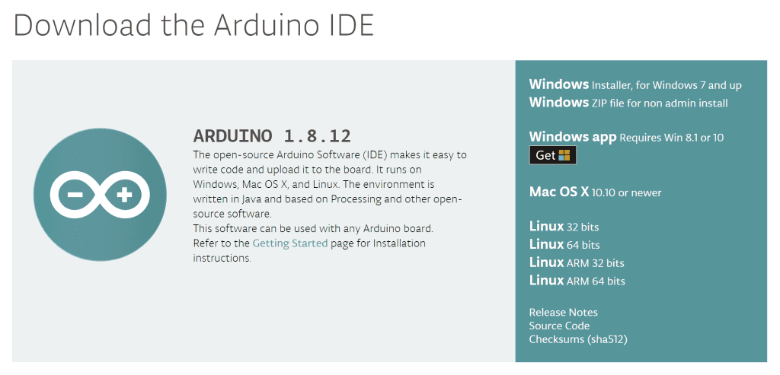

**Fig 3.3 Arduino IDE**

**3. Timing and Display Management**

A dedicated function assigns time-based labels for each pill to help categorize the dosage. The LCD is used to show real-time information such as pill count, reminder messages, dispensing status, and final completion messages.

**4. Testing and Validation**

The system was tested in multiple conditions to ensure accurate pill detection, proper servo rotation, and reliable timing. Adjustments were made to the servo angle, buzzer alerts, and delays to ensure consistent operation. The wiring connections were verified to prevent power drops that could affect the servo motor. After successful testing, the system performed consistently and dispensed each dose correctly.

**5.Final Implementation**

Once the hardware and software were integrated and tested, the complete Smart Medicine Dispenser was assembled. The entire setup works autonomously and provides an interactive, safe, and user-friendly solution for medication management.

Top of Form

Bottom of Form

**HARDWARE AND SOFTWARE REQUIREMENTS**

**CHAPTER:4**

**HARDWARE AND SOFTWARE REQUIREMENTS**

* 1. **Hardware Requirements**:
* Arduino UNO
* Jumper wires
* Servo motor
* Buzzer
* IR Sensor
* 16x2 LCD(I2C)
* Breadboard
* Medicine container
  1. **Software Requirements:**
* Arduino IDE

**4.1Hardware Requirements**

**4.1.1 Arduino UNO:**

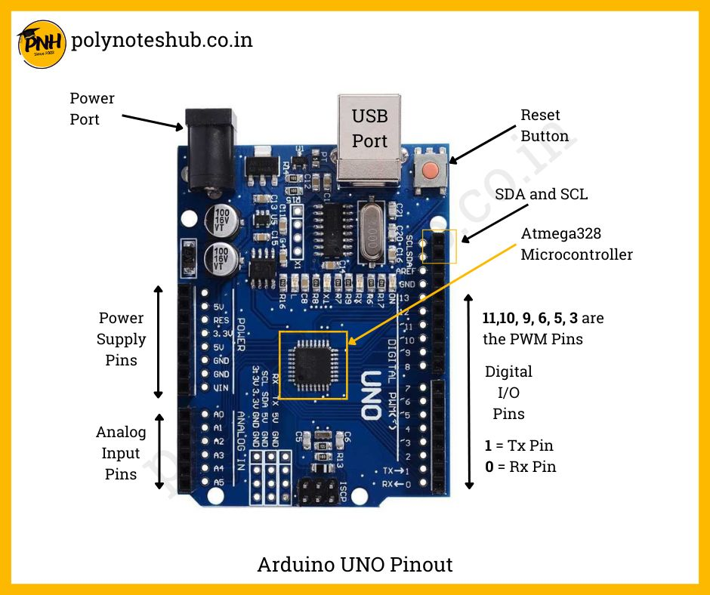

**Fig 4.1.1 Arduino UNO**

| **Pin Type** | **Pin Numbers** | **Purpose** |
| --- | --- | --- |
| Digital I/O Pins | D0–D13 | Read/Write HIGH or LOW |
| PWM Pins | D3, D5, D6, D9, D10, D11 | Motor control, dimming, speed control |
| Analog Input Pins | A0–A5 | Reads voltage between 0–5V |
| Power Pins | 5V, 3.3V, GND, VIN | Power supply |
| Serial Communication | D0 (RX), D1 (TX) | Data transmission |
| I2C Pins | A4 (SDA), A5 (SCL) | LCD, sensors |
| SPI Pins | 10, 11, 12, 13 | High-speed modules |
| Reset Pin | RESET | Restarts Arduino |

**4.1.2 Jumper Wires**

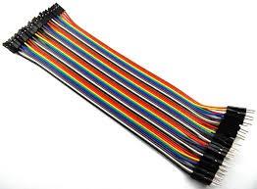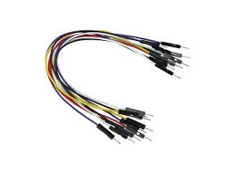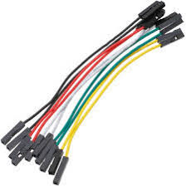 **Male to Male Male to Female Female to Male**

**Fig4.1.2 Jumper Wires**

Jumper wires are essential connecting components used in electronic prototyping to establish temporary electrical connections between the Arduino board, sensors, modules, and the breadboard. They are flexible, insulated wires that allow signals and power to pass from one component to another without the need for soldering. Jumper wires come in three common types—male-to-male, male-to-female, and female-to-female—each used depending on whether the device has pins or sockets. In this smart medicine dispenser project, jumper wires are used to connect the IR sensor, servo motor, buzzer, and the I2C LCD to the Arduino Uno, ensuring proper power supply and signal communication.

**4.1.3 Servo Motor**

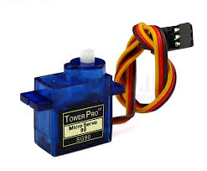 **FIG 4.1.3 Servo Motor**

A servo motor is a specially designed motor used in embedded systems to provide precise control over angular motion. It operates using a small DC motor combined with a series of gears, a feedback sensor, and an internal control circuit that constantly monitors the motor’s position. The motor is driven through Pulse Width Modulation (PWM) signals, where the duration of the control pulse determines the exact angle to which the shaft rotates, usually within a range of 0° to 180°. This ability to move to a specific position and hold it steadily distinguishes servo motors from standard DC motors that rotate continuously. In the smart medicine dispenser system, the servo motor is responsible for executing accurate movement required to release the medicine at the programmed time. Its high reliability, compact size, and ease of interfacing with microcontrollers make it an ideal choice for applications where controlled and repeatable motion is essential, such as robotics, automation devices, and precision mechanisms.

Top of Form

Bottom of Form

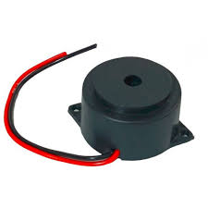**4.1.4 Buzzer**

A buzzer is an electronic sound-producing component commonly used in embedded systems to provide audible alerts or notifications. It works by converting electrical signals into sound through the vibration of a thin metallic or ceramic diaphragm inside the device. In most Arduino-based projects, a piezo buzzer is used, which generates sound when a varying electrical signal is applied to it. By controlling the frequency of the signal using functions such as *tone()* in Arduino, different beep patterns and alert tones can be produced. In the smart medicine dispenser, the buzzer serves as an important alert mechanism that notifies the user when it is time to take the medication or when a pill has been successfully dispensed.

**4.1.5 IR Sensor**

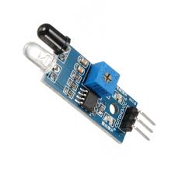

An Infrared (IR) sensor is an electronic device that detects the presence of an object or measures distance by using infrared light. It typically consists of an IR LED that emits infrared radiation and a photodiode or phototransistor that receives the reflected light. When an object comes in front of the sensor, the emitted IR light bounces back to the receiver, causing a change in the output signal. This change is processed to determine whether an object is present. IR sensors are widely used in automation, obstacle detection, counting systems, and proximity-based devices due to their fast response and low cost. In the smart medicine dispenser project, the IR sensor plays a crucial role in detecting the pill in the dispensing channel. When the sensor identifies a pill, it triggers the system to rotate the servo motor and activate the buzzer. Its simple design, easy connectivity with Arduino, and reliable detection capability make IR sensors highly suitable for embedded system applications.

**4.1.6 16x2 LCD Display**

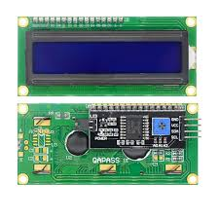**Fig 4.1.6**

A 16x2 LCD display with I2C interface is a compact alphanumeric module capable of showing 16 characters per line across two lines, making it suitable for embedded system applications where simple text output is required. The I2C version of the LCD includes an interface module with a PCF8574 I/O expander, which reduces the number of Arduino pins needed for communication from 6 to just 2 (SDA and SCL). This makes wiring simpler and frees up digital pins for other components in the project. The display operates by receiving data through the I2C protocol, allowing characters, messages, and status updates to be shown efficiently. In the smart medicine dispenser, the 16x2 I2C LCD is used to display important information such as system status, pill count, alerts, and medicine dispensing messages.

**4.1.7 Bread Board**

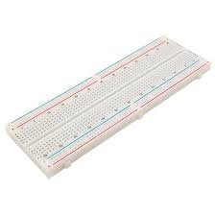

A breadboard is a reusable prototyping platform used to build and test electronic circuits without the need for soldering. The horizontal rows at the top and bottom of the breadboard function as power rails, used for distributing 5V and GND across the circuit, while the central area contains vertical columns used for placing components like resistors, sensors, and modules. In the smart medicine dispenser project, the breadboard serves as the main platform for connecting the IR sensor, buzzer, servo motor, and LCD display to the Arduino Uno. It simplifies circuit assembly, supports troubleshooting, and allows modifications without damaging components.

**4.1.7 Medicine Container**

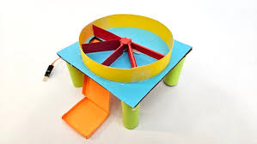

**Fig 4.1.7**

The medicine container is an essential part of the smart dispensing system, responsible for securely holding and organizing the pills before they are released. It is typically designed with small compartments or a funnel-like structure that ensures only one pill moves toward the dispensing mechanism at a time. The container must be lightweight, non-reactive, and hygienic to maintain the quality and safety of the medicines. In the smart medicine dispenser, the container works together with the servo motor and IR sensor to ensure controlled and accurate dispensing. When the system is triggered, the servo rotates to allow a single pill to drop from the container into the output slot, while the IR sensor verifies successful dispensing. A well-designed medicine container prevents clogging, ensures smooth flow of pills, and enhances the overall reliability of the device. Its simple yet efficient design makes it suitable for automated medication systems and healthcare-based embedded applications.

**4.2 Software Requirements:**

**4.2.1 Arduino IDE**

The Arduino Integrated Development Environment (IDE) is a user-friendly software platform used for writing, compiling, and uploading programs to Arduino microcontrollers. It supports the C/C++ programming language and provides a simple interface that includes a code editor, a message console, and a one-click upload feature for transferring code to the board. The IDE also contains a large collection of built-in libraries that simplify tasks such as controlling sensors, displays, motors, and communication modules. In the smart medicine dispenser project, the Arduino IDE is used to develop and upload the program that controls the servo motor, IR sensor, buzzer, and LCD display. The software enables easy debugging, real-time monitoring through the Serial Monitor, and smooth integration with external modules. Its simplicity, cross-platform support, and extensive community resources make the Arduino IDE an essential tool for beginners and advanced developers working on embedded systems and automation projects.

**Writing Sketches:**

Writing sketches in the Arduino environment refers to creating programs that define how the microcontroller should behave. A sketch is essentially a C/C++ based code file written inside the Arduino IDE, consisting of two main functions: setup(), which runs once to initialize components, and loop(), which runs continuously to execute the main tasks of the system. Through writing sketches, users can control hardware devices such as sensors, motors, displays, and communication modules by using built-in functions and libraries. It is possible to open this files with version 1.0,you will be prompted to save the sketch with .inoextension on save.

Verify Checks your code for errors compiling it. Upload compiles your code and uploads it to the configured board. See uploading below for details. New creates a new sketch and write the codes it save on your sketches.

**Edit**

Undo/Redo goes back of one or more steps you did while editing ,when you go back ,you may go forward with Redo. Go to tools from the menu bar, select board option then select Arduino UNO. In the same menu, select the COM port on which your development board is connected To find out the right COM port, screen disconnect your board and reopen the menu. The entry that disappears should be the right COM port. Now upload the code.

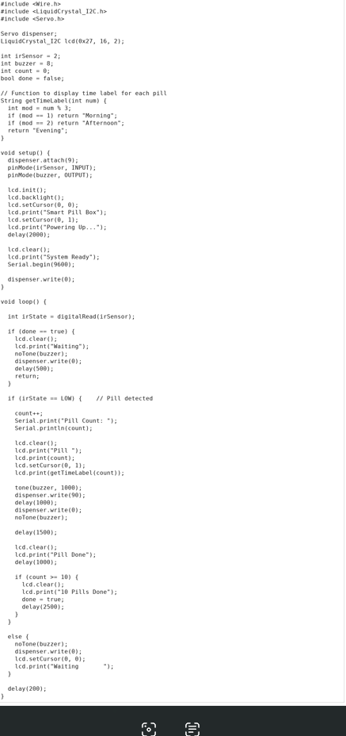CODE:-

**RESULT**

**CHAPTER-5**

**RESULT**

The smart medicine dispenser system was successfully designed, programmed, and tested using Arduino Uno, an IR sensor, a servo motor, an I2C LCD display, and a buzzer. During testing, the IR sensor accurately detected the presence of each pill, triggering the programmed sequence. The buzzer provided a clear audio alert to notify the user when it was time to take the medicine. The LCD display showed messages such as system readiness, pill count, and dispensing status, allowing easy user interaction. The servo motor rotated smoothly to dispense a single pill at a time, and the mechanism consistently returned to its original position after dispensing. The system operated reliably for all ten pill cycles without malfunction, demonstrating its ability to automate medicine management effectively. The results confirm that the prototype can reduce manual errors, improve reminders, and provide a simple yet efficient solution for medication dispensing in daily use.

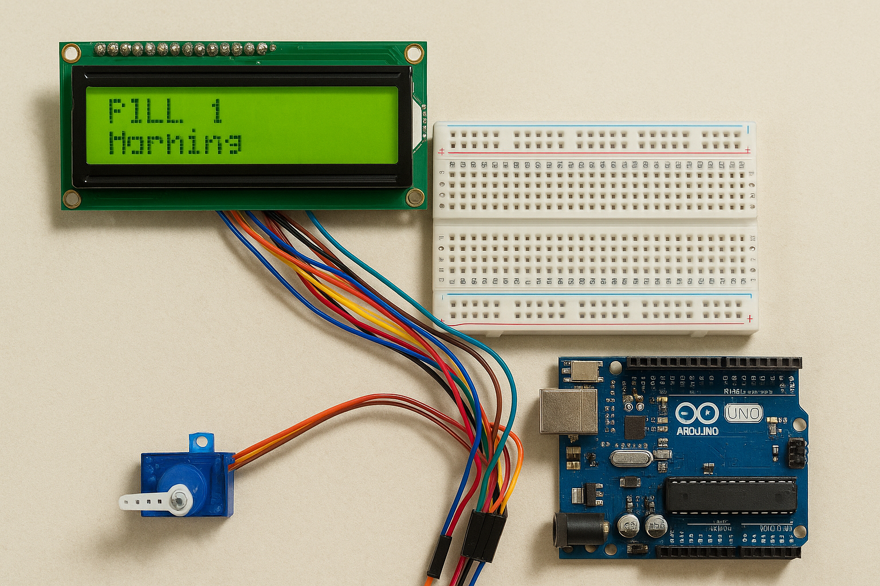

**Fig 5.1 Hardware Working**

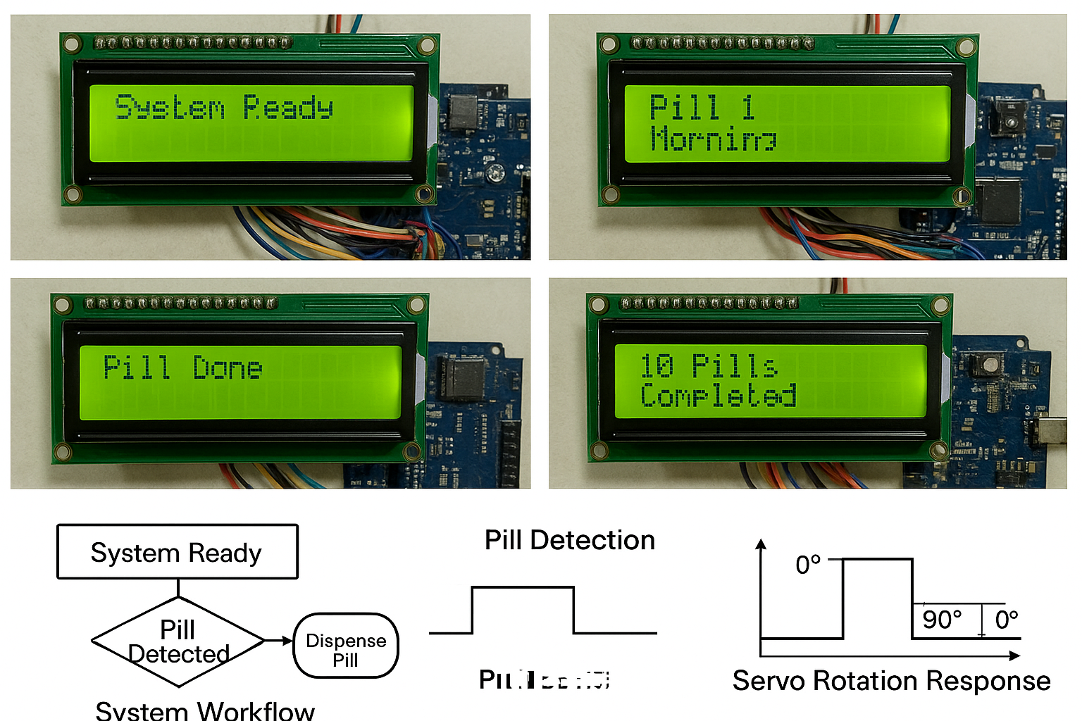

**Fig 5.2 System workflow and Results of diagram**

**ADVANTAGES AND DISADVANTAGES**

**CHAPTER 6**

**ADVANTAGES**

1. **Timely Medication Alerts:**  
    The buzzer and LCD display provide clear reminders, reducing the chances of missing doses.
2. **Accurate Pill Dispensing:**  
    The servo motor releases only one pill at a time, preventing wrong or excess consumption.
3. **Improved Hygiene:**  
    Pills are dispensed automatically without direct hand contact, keeping the process clean.
4. **User-Friendly Operation:**  
    The LCD display shows clear instructions, making it easy for anyone to use.
5. **Reliable Pill Detection:**  
    The IR sensor accurately detects pill removal and ensures proper pill count tracking.
6. **Cost-Effective System:**  
    The use of Arduino and basic sensors makes the project affordable and easy to maintain.
7. **Reduction of Human Error:**  
    Automation minimizes mistakes in timing and dosage.
8. **Suitable for Elderly and Patients:**  
    The system helps people who forget regular medication schedules.
9. **Easy to Modify and Upgrade:**

The Arduino-based platform allows future enhancements like Wi-Fi alerts or mobile notifications.

1. **Portable and Compact:**

The system is lightweight and can be placed anywhere in the home for daily use

11. **Enhanced Safety:**  
 The system reduces the risk of double-dosing by keeping track of the number of pills dispensed.

12. **Consistent Performance:**  
 The automated mechanism ensures the same reliable operation every time without manual intervention.

13. **Low Power Consumption:**  
 Components like the Arduino Uno, IR sensor, and servo motor consume minimal power, making the system energy-efficient.

14.**Easy Troubleshooting:**  
 The Serial Monitor in Arduino IDE helps identify and fix issues quickly during operation or maintenance.

**DISADVANTAGES**

1. **Limited Storage Capacity:**  
    The system can hold only a small number of pills, making it unsuitable for large medication schedules.
2. **No Real-Time Clock (RTC):**  
    Without an RTC module, the system cannot dispense medicine based on actual time unless manually programmed.
3. **Manual Refilling Required:**  
    The container must be refilled by the user or caretaker, and forgetting to refill can interrupt the process.
4. **Mechanical Wear and Tear:**  
    The servo motor and moving parts may wear out over time, affecting accuracy and consistency.
5. **IR Sensor Limitations:**  
    The IR sensor may give false readings under strong lighting conditions or if the pill is too small or transparent.
6. **No Remote Monitoring:**  
    The system cannot send mobile notifications unless additional Wi-Fi modules are added.
7. **Power Dependency:**  
    The system stops working during power failures unless a backup battery is added.
8. **Not Suitable for Liquid Medicine:**  
    The device can handle only solid pills, and cannot manage syrups or tablets that vary in size.
9. **Calibration Needed:**  
    The servo rotation and pill slot size must be accurately aligned, which requires careful setup.
10. **No User Authentication:**  
     Anyone can take medicine from the dispenser, as it does not have fingerprint, password, or lock security.
11. **Not Fully Automatic for Multiple Users:**  
     The system cannot differentiate between different patients; it supports only one user at a time unless modified.
12. **Limited Dose Variety:**  
     The dispenser works best with round or small tablets; irregular shaped medicines may not dispense smoothly.

**APPLICATIONS**

**CHAPTER 7**

**APPLICATIONS**

9The smart medicine dispenser project has various applications in:

* **Healthcare:** Improving medication adherence and patient outcomes in hospitals, clinics, and home care settings.
* **Elderly Care**: Assisting elderly patients with managing their medication regimens, promoting independence and reducing caregiver burden.
* **Chronic Disease Management**: Helping patients with chronic conditions, such as diabetes or hypertension, adhere to their medication regimens and manage their conditions effectively.
* **Palliative Care**: Providing patients with palliative care with timely and accurate medication administration, improving their quality of life.
* **Home Healthcare**: Enabling patients to receive care in the comfort of their own homes while ensuring adherence to medication regimens.
* **Clinical Trials**: Improving medication adherence and data collection in clinical trials, enhancing the validity and reliability of results.
* **Pharmaceutical Industry**: Providing a platform for pharmaceutical companies to develop and implement smart medication packaging and delivery systems.

**CONCLUSION**

30

**CHAPTER-8**

**CONCLUSION**

The Smart Medicine Dispenser system was designed and implemented successfully using Arduino-based hardware and simple electronic components. The primary objective of providing an automated and reliable method to dispense medicines at the correct time was achieved effectively.

The integration of an IR sensor ensured accurate detection, while the servo motor mechanism enabled smooth dispensing of tablets. The buzzer and I2C LCD display enhanced user interaction by providing timely alerts and clear messages on the device status.

Overall, the system operates efficiently, reduces manual involvement, and helps users—especially elderly individuals—follow their medication schedule without confusion or delay. This project demonstrates how embedded systems can be applied to healthcare automation in a cost-effective and user-friendly manner. With further improvements such as mobile app connectivity, battery backup, or multi-compartment dispensing, the project can evolve into a more advanced and practical solution suitable for real-world use.

The project successfully meets its primary objective of reducing human error in medication schedules, which is especially beneficial for elderly patients, busy individuals, and those with chronic illnesses. The buzzer alert ensures the user is notified at the right time, while the LCD screen provides clear and immediate feedback during each stage of operation.

The servo mechanism delivers controlled movement for dispensing, and the IR sensor ensures reliability by confirming pill dispensing actions. This prototype highlights how low-cost microcontroller-based systems can significantly improve healthcare support at home. It also proves that automation can play an essential role in enhancing patient compliance and reducing dependency on caretakers. The system is simple to operate, energy-efficient, and adaptable for future upgrades.

**FUTURE SCOPE**

**CHAPTER-9**

**FUTURE SCOPE**

The Smart Medicine Dispenser has significant potential for development and real-world application. Several enhancements can be made to improve its functionality, reliability, and user convenience. One major area of expansion is the integration of IoT technology, which would allow the device to send notifications to smartphones, alert caregivers remotely, and maintain medication logs. Adding Wi-Fi, Bluetooth, or GSM modules can transform the system into a connected health monitoring tool.

Another promising improvement is the inclusion of multiple compartments for storing different types of medicines. This would enable the device to support complex medication schedules and provide automatic dispensing for multiple doses throughout the day. Incorporating a real-time clock (RTC) module will help maintain accurate timing even during power outages. Additionally, a rechargeable battery or power backup system can improve portability and ensure continuous operation.

Future versions may also include a touchscreen interface, voice alerts, or an Android app to enhance accessibility for elderly users and patients with disabilities. Sensors such as weight sensors or load cells can be added to verify whether the patient has actually taken the medicine. The design can also be made more compact, durable, and aesthetically appealing for commercial manufacturing.

Overall, the Smart Medicine Dispenser holds strong potential for advancement into a fully automated, connected, and intelligent healthcare assistant capable of supporting medication adherence in homes, hospitals, and elderly care centres.

Top of Form

**REFERENCES**

**CHAPTER-10**

**REFERENCES**

1. Nidhi Solanki, and DR. P. H. Zope International Research Journal of Engineering and Technology, Volume: 05, Issue: July 2018, e-ISSN: 2395-0056.

2 .Diaa Salama Abdul Minaam, and Mohamed Abd-ELfattah, Smart drugs: Improving healthcare using Smart Pill Box for Medicine Reminder and Monitoring System, Future Computing and Informatics Journal, Volume 3, Issue 2, 2018, ISSN 2314-7288.

3. Ekbal Rosli and Yusnira Husaini 2018 IOP Conf. Ser.: Mater. Sci. Eng. 341 012004.

4. Abdallah Kassem, A Comprehensive Approach for A Smart Medication Dispenser,International Journal of Computing and Digital Systems, March 2019, ISSN 2210-142X.

**Bottom of Form**